Game Design Document
Fill up the following document

- Write the title of your project.
SQUAD MASTER

- What is the goal of the game?
TO CACTH THE MURDERER OR ROBBER

- Write a brief story of your game.
In the town of Minecity lived a king. He was facing continuous threat and terrible political seat-back from antisocial people! So he decided to call the police Harry to get them out of the estate.

- Which are the playing characters of this game?
- Playing characters are the ones who respond to the user based on the input from the user.
- Cars, monkeys, dinos, wizards, etc., are the playing characters in the game.

Number | Character Name | What can this character do?
1 | King Rana Pratap Sing | Can order Harry
2 | Harry | Can catch the Murderer and Robber
3 | Murderer | Can Complete Tasks
4 | Robber | Can Complete Tasks
5
6
7
8

- Which are the Non-Playing Characters of this game?
- Non-Playing characters are the ones that don't have an action or behavior when the user interacts with the game.
- Hurdles, stones, bananas, coins, etc., are non-playing characters in the game.

Number | Character Name | What can this character do?
1 | - | -
2 | - | -
3 | - | -
4 | - | -
5 | - | -
6 | - | -
7 | - | -
8 | - | -

Draw your imagination of this game. What does this game look like?
- Draw the game either on your computer or on paper.
- Add images of the game scenes to show each of the playing and non-playing characters at least once.
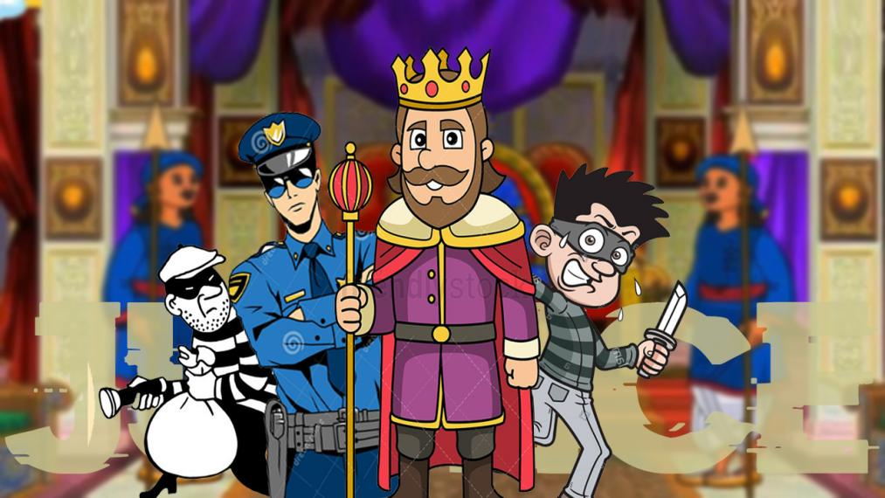

How do you plan to make your game engaging?

There are animations and Challenges given to each member and with only one chance to catch the thief ! Ranks are given accordingly!

